Current word count, 2707/2750

Abstract:
The numbers of pollinators have been in decline, with a 25% loss of domesticated bee colonies in Europe between 1985-2005 (reference). This is important as insect pollination is necessary for 75% of all crops used worldwide for human consumption (Klein, 2007). By assessing whether the 2020 lockdowns had an impact on the levels of pollinators and pollinated plants, this study will review whether the changes (Intended or unintended) that we made during this time as humans can be preserved to slow this fast decline of pollinators to benefit the human race, as 8.9% of the world is starving (World Vision, 2014). Abstract should also include results as it is a summary of the whole text to give the reader a quick idea of the whole paper.

Introduction
Lockdowns, the imposition of strict restrictions on travel, social interaction, and access to public spaces, (Collins Dictionary2020), placed one third of the world’s population indoors (BBC, 2020) in order to stop the spread of Coronavirus, a severe acute respiratory syndrome. Across the world, non-essential businesses stopped, schools and offices closed, and people remained indoors. Households were no longer allowed to mix, and people were unable to travel out of their local area.
Since the first instance of Coronavirus being present in the UK, there has been a series of varying ‘lockdowns’. For ease, I have attempted to categorise these into timeframes:
- The First Lockdown, 16th March 2020 – 17th July 2020, from the announcement of initial restrictions to when the UK’s COVID-19 Alert level is lowered from Level 4 (severe risk, high transmission) to Level 3 (Substantial risk, general circulation), meaning a gradual relaxation of restrictions and social distancing measures, and non-essential journeys are permitted.
- The Middle Phase, 17th July 2020 – 14th September 2020 Where restrictions varied depending on location and some local lockdowns were enforced in high risk, high case areas such as Leicester and Birmingham.
- The Second Wave Lockdown, 14th September 2020 – Localised lockdowns are defined by the ‘Tier’ system put in place in October.

These different levels of lockdown had different levels of restriction as those in power became more aware of the effect of the virus and understanding increased of what was deemed ‘essential and ‘non-essential’. This variation is important to consider when answering my research question, as much of it is dependent on what work continued during this time, and what stopped.
During The First Lockdown, maintenance work in places and their parks stopped, there were no cars on the roads, the people were still. The purpose of this paper is to see if this reduction in human activity, through reduced maintenance of natural areas, less noise, air and water pollution due to reductions in tourism and transport meant that ecologies, specifically in urban locations, were able to thrive due to an increase of movement possibility, habitats and foraging possibilities of pollinators
For the purpose of this paper, I will be focusing solely on pollinator species, looking at both wild and domesticated honeybees. I will also be concentrating on the pollinators species specifically in urban environments, as pollinators have been known to struggle in these environments, and if any change can be noticed it will be most drastic here, as the reduction in pollution will also be measurable here.

Pollinators are a species, usually an insect, that carries pollen from one plant to another, defined by the Cambridge Dictionary. 80% of wild plant species are dependent on insect pollination for fruit and seed, and insect pollination is necessary for 75% of all crops used for human food worldwide (Klein, 2007). Despite this level of necessity, pollinators are in decline, with a 59% loss of domesticated bee colonies in the USA between 1947-2005, and a 25% loss of domesticated bee colonies in Europe between 1985-2005 (reference). This worldwide decline negatively correlates with the rising population, and rising food demand. According to Klein, 2007, the agricultural crops dependent on pollinators have increased by 300%. The numbers of these declines are worrying, and changes need to be made to reduce the decline in species variety and richness. By analysing if the reduction in human intervention during the Coronavirus pandemic in 2020 had any effect on the numbers of pollinator species, and their quality of life, it can be assessed whether the cause of these changes can be understood and continued in an effort to slow the decline of our much needed pollinator species.

Additional literature review – bees’ response to rewilding in the past

Method
The primary research consisted of interviews withbeekeepers, Alison and Steve from the Shropshire Beekeepers Association, owners of over 20 beehives in different locations, from their own garden to establishments set up within the association. The Shropshire Beekeepers Association was founded in 1884, and is a founding member of the BBKA, the British Beekeepers Association, a society that promotes the understanding and importance of bees and pollinators, representing 25000 hobbyist beekeepers (BBKA, n.d.). During the interview, the following data was gathered:
- Location
- Level of restrictions
- General bee information, natural habitats, seasonal changes
- Subjective opinion of the popularity of beekeeping over time
- Impact of coronavirus lockdowns, on both them and their bees

The interview will be recorded and transcribed in order to analyse the results.
Thematic analysis was used for the analysis of the interview. Thematic analysis is a method used for identifying, analysing and reporting patterns, or themes, within qualitative data (Braun & Clarke, 2006). I will be using this method to analyse the interview conducted on the 14th December 2020 with keepers of domesticated honeybees, Apis mellifera. This will allow me to assess subjective research in an objective manner.
Thematic analysis can be broken down into these steps, according to Braun and Clarke (2006):
- Familiarise yourself with the data
- Generate initial codes.
- Search for themes
- Review themes
- Define and name themes
- Produce report
I chose the method of thematic analysis as the primary research method I chose was a focus group, which produced qualitative data. When the participants spoke, their answers were often unclear and disorganised, and by determining themes for the whole transcription it meant that no information was lost. For example, when answering a question about classes, the participants would tell me a fact about bees which did not directly answer the question, and through thematic analysis this information was not lost, but redirected into a different theme. Through assessing and grouping the themes it is easier to draw clear conclusions to answer my research question and assess if the Coronavirus Lockdowns in 2020 impacted pollinator species.
Results of analysis:
- Familiarise yourself – focus group transcription
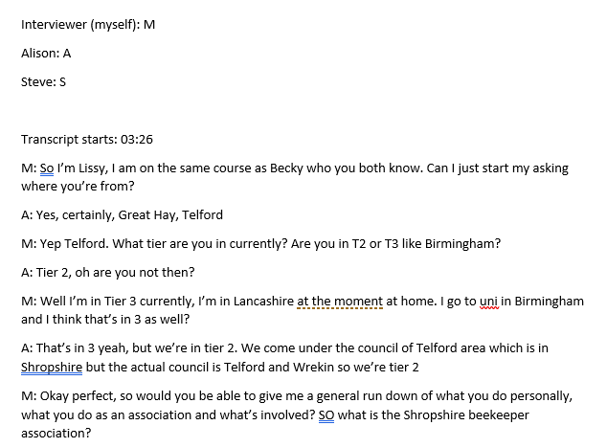

- Generate initial codes
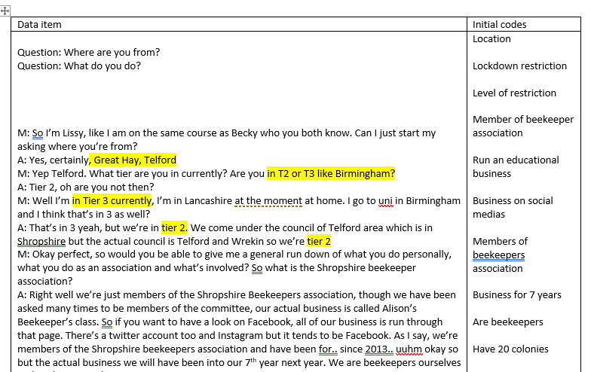
- Search for themes – initial themes
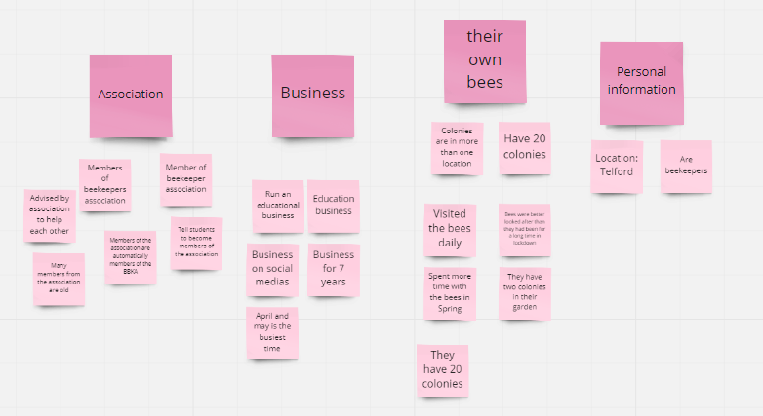
- Reviewing themes and subthemes
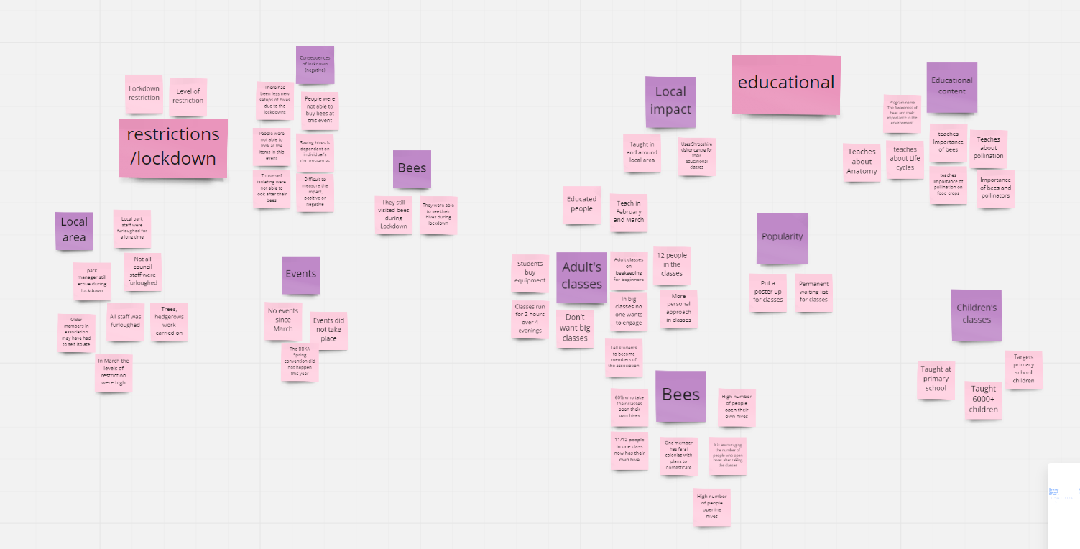

  - Thematic map – the relationship between the themes
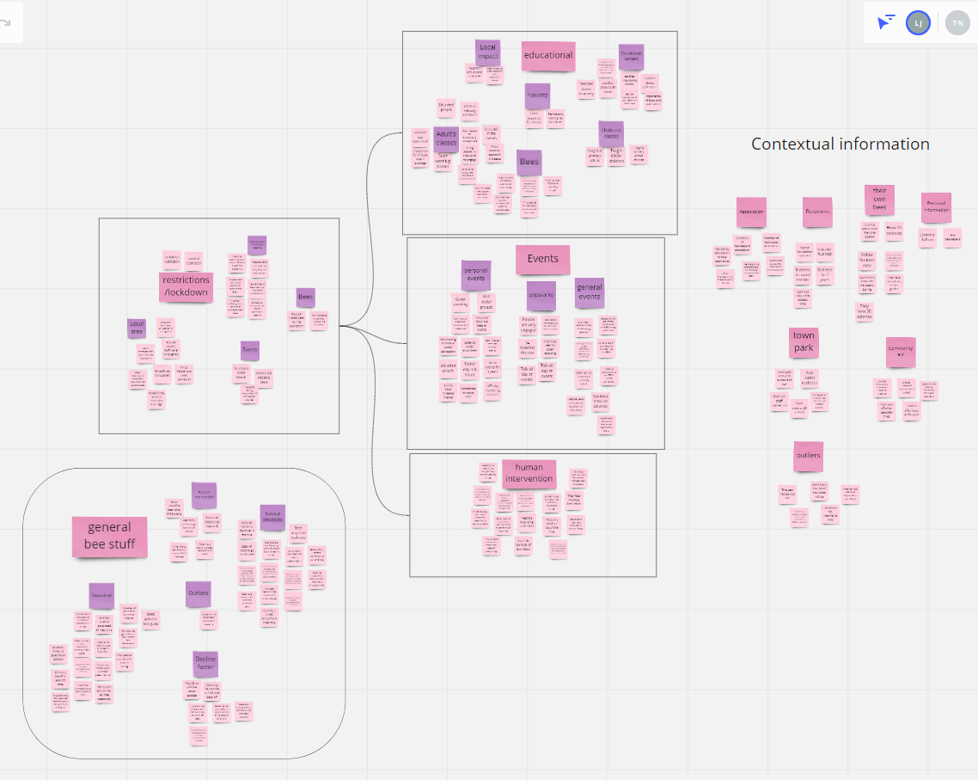

- Defining and naming themes – map
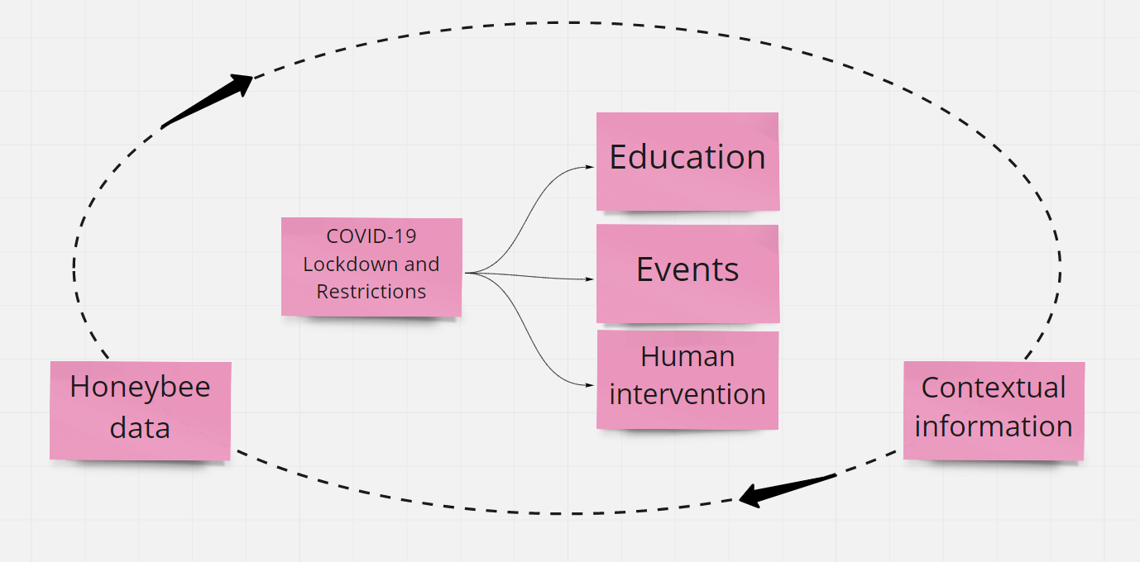
The diagram above outlines the process used for this study. Impact of Covid-19 restrictions on education, events, and human intervention will be assessedwithin the boundaries of the contextual information provided by the focus group specifically for honeybees, referring to that data throughout the exploration process.

- Producing the report – and establishing relevance to research question:

- Covid-19 Lockdown and restrictions
Alison and Steve live in Telford, Shropshire, which at the time of interview (December, 2020) was in Tier 2, defined as ‘High Alert’ (Gov.uk, 2020). The general restrictions for this tier mean only mixing with other households outdoors, some non-essential shops are open, and working is recommended to occur at home but not required. The timeframe focused on in this study will be between The First Lockdown and The Middle Phase, defined previously in the introduction, as in this time between Spring and summer, specifically May and June, honeybees are most active. According to Alison and Steve, “local park staff were furloughed for a long time, though the park manager was still active during the lockdown”. At this time, the UK was in the First Lockdown, with nation measures prohibiting non-essential travel and closing classes and businesses, meaning Alison’s businesses, Alison’ beekeepers and the classes, were unable to run.

  - Education
Alison runs an education programme named ‘The Awareness of bees and their importance in the environment’, teaching about anatomy, lifecycles and the importance of pollinators. She runs 2 sets of classes, one targeting primary school children, with over 6000 children being educated about the importance of pollinators from Alison alone. The second set of classes is given to adults, introducing them to beekeeping at a beginners level. The groups are small, with no more than 12 people per class to encourage greater involvement and engagement. According to both Alison and Steve, 60% of people who attend their classes open their own hives, and in one group, 11/12 attendees became new hive starters, with the 12th already ‘owning’ a set of feral hives. It is reiterated several times by both members of the group that high numbers of people attending their classes open their own hives.
Due to the restrictions, educational facilities were closed and these classes did not continue. Alison said there is a permanent waiting list for the classes, and they would have been fully booked had the lockdowns not occurred. With over 60% of class attendees usually opening their own hives, increasing the general honeybee population, the absence of these classes will reduce the number of hives opening in 2020.
If this impact is felt with just one person’s class, the national impact of this reduction in new hives reopening will be massive (can I give a number to this or predict?) meaning that the number of honeybees, specifically domesticated, will have reduced during 2020.
  - Events
Both interviewees host several of their own events through the year, from guest speaking to community events. There are also three general major events, hosted by the BBKA, that people from all around the world attend, the biggest being the BBKA Spring Convention, a 3-day event. It is established that both personal and general beekeeping events are very popular, with both members reiterating that they speak all day, speaking to the general public about the importance of beekeeping and offering mentoring sessions. People are very engaged, and beekeeping, from these events, is becoming more and more in the public perception. Alison and Steve have run these events and guest speaking for 5 years, with increased interest. Alison was booked in todo 54 speeches this year alone, only some of which went through due to the restrictions.
Because of the restrictions, no events took place this year, the most notable being the Saturday trade show in the BBKA Spring convention. People were not able to buy bees at the event, look into items and equipment or receive the education required to keep and manage their own hives. These cancellations will have direct impact on the number of hives that have opened in 2020, and therefore lead to a reductionof honeybees in 2020.
  - Human intervention
The level of care given to domesticated beehives is dependent on the keeper. Alison and Steve watch their colonies for disease management and pests, providing treatment if needed, ensure the honeybees have food suppliesto last them through winter, and generate new hives with artificial swarms of their own. Though they do not practice organic beekeeping, the keepers are keen to not treat their bees against everything, to give the opportunity to build up resistances to viruses and pests, the most notable being the Veroa Destructor. This Darwinistic approach may not be used in all hives nationally.
During the lockdowns, Alison and Steve were able to visit their hives as domesticated honeybees are classed as livestock. They visited the bees daily, spending most time with them in spring. They said their bees were better looked after than they had been for a long time during lockdown, but it is established by both members that they would have been okay if left alone. Bees have been on the earth for billions of years, and had their care been reduced they would have been fine. The only winter care given to their hives is ‘hefting’, to check the weight of the hive to ensure enough winter stores, otherwise the bees are fed from a sugar block. Had this care not been given, some of the bees would have starved. It is believed by other beekeepers that pests and diseases will kill off all honeybees without human intervention, but clearly enforced by Alison and Steve that they strongly believe bees will be okay if left.
They did however say that many members of their association were older, and those over 70 in the UK were asked to shield (higher levels of restrictions, prohibiting travel), and would have been unable to visit and look after their own bees. Though it was encouraged that members help one another, from the care given by Alison and Steve for their own bees during the colder months, it can be assumed that some hives may not survive the winter without some human intervention through feeding. To conclude, it is difficult to measure the impact that the coronavirus lockdown had on the human intervention given to domesticated honeybees, positive or negative. But...
Secondary research
- Discussion
  - Interpretation of results
Through thisresearch it has become clear that the impact of lockdowns in 2020 on pollinators is difficult to measure, and this is reiterated by the Wildlife Trust, who stated that “The true impact of the coronavirus lockdown on our native pollinators and pollinated plants in urban and rural areas will not be apparent for a number of years, as the data is yet to be collected and the knock on effects are not yet clear.” Though through the thematic analysis of the interview with a focus group, from all three key categories, education, events and human intervention, it can be assumed that the number of honeybees will have reduced in 2020, with very few new hives being opened nationally and unattended hives dying off in the winter months due to lack of food. The impact on pollinators, specifically honeybees, has been negative, and changes to human movement brought about through the Coronavirus lockdowns, both nationally and worldwide, have not shown evidence of reducing the decline on pollinator species.
  - Other important findings / outliers
My main hypothesis for this paper was that levels of pollinator species and animal-pollinated plants would have increased due to a lack of maintenance of park areas and public spaces, allowing for grass verges and wildflowers to grow, increasing habitat and foraging opportunities for pollinator species. From my discussion with Steve and Alison, I learned bees, who live in hives, only travel a 3 mile radius from their hive to forage, so the lack of maintenance is unlikely to have affected honeybees directly, but is unknown for other pollinator species such as hoverflies. On the other hand, the number of vibrations caused by human movement reduced significantly during the lockdown which may have made the journey to forage sites for pollinators easier, but there is little evidence to support this.
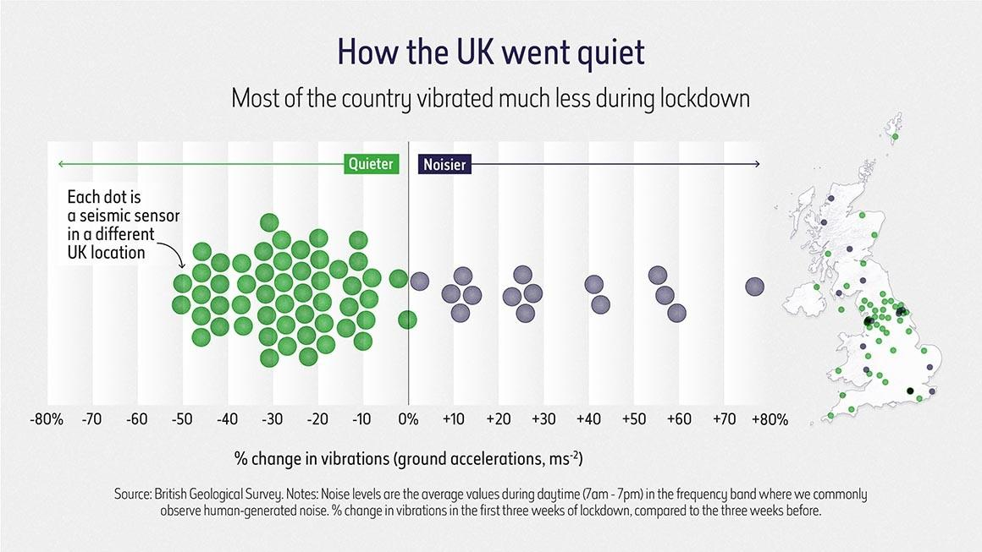
(Natural History Museum, 2020)
  - Implications and Limitations
Implications
The reduction of new hives opening due to a lack of information and education given at events and classes is worrying when it is considered how important pollinators are for human food. From this, the importance of this education and keeping beekeeping into the human perception is highlighted, and should continue and increase after the pandemic is over.
Limitations
I conducted my research process from October – November 2020, months in which the number of pollinator species are greatly reduced, due to a lack of foraging opportunities in the winter months. This meant I was not able to go out and record numbers of sighted pollinators or pollinated species as primary research. This may have been stronger than my conducted research, interviews with a focus group, as it would have provided quantitative data as opposed to qualitative, which is easier to analyse. Though, the discussion of ‘impact’ is often approached subjectively. Another limitation came from personal experience, as I was travelling and had to self isolate meaning that I was unable to leave my house to conduct in person interviews or collect primary data of pollinators and animal pollinated plants.
Limitation is also that you researched non wild bees so it is hard to say something about wild bees through the research. You can do some guesses but future research can be done to assess impact on wild bees. Often papers mention directions for future research in the discussion.
Summary
Not sure what to write here as I covered a lot in my conclusions!

